STATEMENT REGARDING TIME TAKEN OFF FOR TRADE UNION OFFICIALS

During the Academic Year 2022-23 there were no members of staff who were Trade Union Officials.

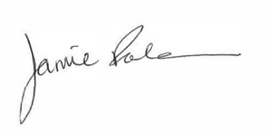
_________________
J Rockman
Executive Headteacher

